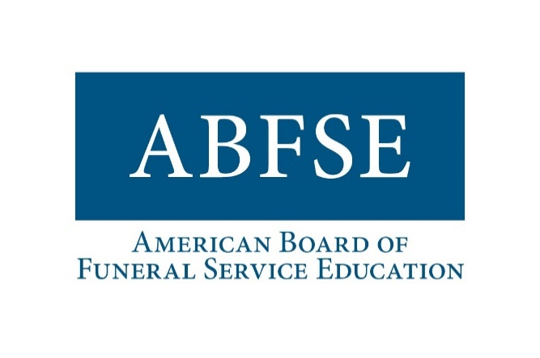

Accreditation Manual Comment Form

Submission Deadline: Wednesday, October 15, 2025 at 5:00 PM

Name: Click or tap here to enter text.
Date: Click or tap here to enter text.

INSTRUCTIONS:
- Use the form below for your comments.
- Please be specific and clear to reference the source location related to your comment.
- Send completed form to Trudy Ellmore - trellmore@abfse.org.
- Deadline: 5:00 PM on October 15, 2025. Comments received after this date will not be considered.

Chapter | Section | Line # | Comment
Hit tab to add another line.

